Report On

TOURIST MANAGEMENT SYSTEM

Submitted in partial fulfillment of the requirements of the Mini project in
Semester III of Second Year Artificial Intelligence & Data Science Engineering

by
Pratik Sanjay Avhad (01)
Priyanka Narendra Bhandari (02)
Swarup Satish Kakade (19)

Under the guidance of
Prof. Sejal D’mello
Prof. Neha Mahesh Raut



University of Mumbai

Vidyavardhini's College of Engineering & Technology

Department of Artificial Intelligence and Data Science

(A.Y. 2023-24)



CERTIFICATE

This is to certify that the Mini Project entitled “TOURIST MANAGEMENT SYSTEM ” is a bonafide work of Pratik Sanjay Avhad (01), Priyanka Narendra Bhandari (02), Swarup Satish Kakade (19), submitted to the University of Mumbai in partial fulfillment of the requirement for the award of the degree of “Bachelor of Engineering” in Semester III of Second Year “Artificial Intelligence and Data Science”.

_____________________  Ms. Sejal D’mello  Guide |  | _____________________  Ms. Neha Raut  Co-Guide
________________ | ____________________ | _______________
Ms. Sejal D’mello  Deputy HOD AI & DS | Dr. Tatwadarshi Nagarhalli  HOD AI &DS | Dr. H.V. Vankudre  Principal



Mini Project Approval

This Mini Project entitled “TOURIST MANAGEMENT SYSTEM” by Pratik Sanjay Avhad (01), Priyanka Narendra Bhandari (02), Swarup Satish Kakade (19) is approved for the degree of Bachelor of Engineering in in Semester III of Second Year Artificial Intelligence and Data Science.

Examiners

1………………………………................
(Internal Examiner Name & Sign)

2…………………………………………
(External Examiner name & Sign)

Date:
Place:

Contents

Abstract i

Acknowledgment ii

List of Abbreviation iii

Introduction 1
  - Introduction
  - Problem Statement & Objectives
  - Scope

- Literature 2

  - Survey of Existing System/SRS
  - Limitation Existing system or Research gap
  - Mini Project Contribution

Proposed System 4

  - Introduction
  - Architecture/ Framework/Block diagram
  - Algorithm and Process Design
  - Details of Hardware & Software
  - Implementation and Results for Validation and Verification
  - Analysis
  - Conclusion and Future work.

References 9

Abstract
The “Tourist Management System” is comprehensive software designed for the travel industry . It is dynamic and responsive system that addresses issues as document management, lost records due to human error. The goal is to create a system that handles all aspect of travels that help customer as well as industries.
Identification of the drawbacks of the existing system leads to the designing of computerized system that will be compatible to the existing system with the system Which is more user friendly and more GUI oriented.
This project offers a user-friendly platform for tourists to plan and book their trips, accommodations, and activities. It also assists tour operators and destination management organizations in efficiently organizing and promoting tourism services. This application is based on the idea that travelers rely on other.
Some key point in this system that can overcome problems arising in the existing system as less human error as its totally software-based, data recovery possible , manage the different aspects of user at a time.

Acknowledgments

I would like to thank all people whose support and cooperation has been an invaluable asset during this Project. I would also like to thank our Guide Prof. Ms. Neha Mahesh Raut, for guiding me throughout this project and giving it the present shape. It would have been impossible to complete the project without his/her support, valuable suggestions, criticism, encouragement, and guidance.

I convey my gratitude to Dr. Tatwadarshi Nagarhalli, Head of Department, for his motivation and providing various facilities, which helped us greatly in the whole process of this project. I am also grateful to all other teaching and non-teaching staff members of the Artificial Intelligence and Data Science Department for directly or indirectly helping us with the completion of projects and the resources provided.

------------------------------
Pratik (01)

------------------------------
Priyanka (02)

------------------------------
Swarup (19)

Date:

List of Abbreviations

- HTML:- Hypertext markup language.

- CSS:- Cascading Style Sheets.

- JS:- JavaScript.

- PHP:- Hypertext preprocessor.

- SQL:- Structured Query Language.

- Introduction

Travel is the movement of people between distant geographical locations. Travel can be done by foot, bicycle, automobile, train, boat, bus, airplane, ship or other means, with or without luggage, and can be one way or round trip.[1]

A travel website is a website that provides travel reviews, trip fares, or a combination of both. Over 1.5 billion people book travel per year, 70% of which is done online.[2]

According to the United Nations World Tourism Organisation (UNWTO), tourism entails the movement of people to countries or places outside their usual environment for personal or business/professional purposes.

Tourist management system is used to book a tour from anywhere in the INDIA by a single dynamic website which will help the user to know all about the places and tour details in a single website. The admin can add packages to the website from a certain travel agents and hotels by create a tour page. Then the users can sign in and book each project. It is a easiest platform for all travelers which can be easily booked and know the all details. Tour Management system is a dynamic website for tourism business.[4]

Weekends goal is to demonstrate the feasibility and functionality of such a system, showcasing its potential to revolutionize tourist management. Tourist management system is not just a modern convenience; it represents a significant step towards a more efficient, secure, and affordable way of managing tourist.

1.1 Overview

Weekends is a Online Travel Management Website used to view packages, gallery, and user can explore the cities. The main aim of Weekends is to provide good facilities to user through online.

1.2 Problem Statement & Objective

Problem Statement:

India is a country where in a few days holiday, you can enjoy a lot .The problem is that we although having many websites but they offer different kind of services .The customers are enjoying a lot but there is a lack of relationship between travel agency and customers and hence we are establishing that relationship by caring and serving all customers in the same manner that we wish to be served.One of the main purposes of the website is to facilitate the offline customer online because customers cannot spend their precious time in markets trying to find out the best deal and provide them good facilities and right information. Because of the manual maintenance there are number of difficulties and drawbacks exist in the system. Since the last few years, Indian tourism industry has been growing at a rapid pace.

Many tourism-related activities have been suspended due to the nationally enforced lockdown to combat the Corona-virus pandemic. The tourism industry suffered immensely from the lockdown, and as a result of this, digital tourism began gaining traction and attracted public attention.

Weekends is here to provide the facilities to user and to provide information of some cities and give preview of hotel and flights.

Objectives:

Our priority will be our customers and their travel requirements.
- Interface :-
There will be many users visiting the portal and hence we require a strong and reliable front end which can withhold the users on our site.

- Efficiency :-
The data we will be consisting is very important that can help everyone and hence we need a strong database.

- Cheapest:-
To offer the traveling services at very reasonable prices.

- Contact Us :-
We need to build a world class team armed with knowledge and backed by technology to advise customers in planning of their holidays and to answer their queries.

- Accuracy:-
We will be putting an effort to provide the right choice to the people when they plan a holiday and beware them from the false advertising.

- Simple:-
The purpose of travel sites is to make it easier for people to plan their trip.
They provide a wide range of services, from helping you find the best deals on flights and hotels, to providing detailed information about destinations around the India.

1.3 SCOPE

This website serves as a comprehensive platform for travelers and tourism service providers. This website can offer features like user registration, itinerary planning, hotel and transportation booking, and reviews. Travelers can explore destinations, create customized itineraries, book accommodations, flights, and tours, and view packages. Additionally, user can view map.
For tourism service providers, the website can include tools for managing inventory, tracking reservations. Furthermore, data analytics can be integrated to offer insights into travel trends and customer preferences. Overall, a tourist management system website provides a robust and user-friendly interface for both travelers and industry professionals.

2. Literature Survey

Edt. , “Travel Planning Management System”, Volume 12, October 2022
This research, "TRAVEL PLANNING MANAGEMENT SYSTEM", is used to automate all processes of travel and tourism, which deals with the creation, booking, confirmation, and user details. The project is designed with React JS as the front end and Spring boot as the backend, which works in any browser. A travel planning management system is used to book a tour from anywhere in the world by a single dynamic website which will help the user to know all about the places and travel details in a single web application. The admin can add transport services, place management, and hotels to create travel packages. Then the users can sign in and book each travel package, and also, they can book custom travel packages. The user can confirm their bookings by paying for the package.[2]

Some of them are Drawbacks of the Existing System:
- Increased transaction leads to increased source document and hence maintenance becomes difficult.
- If any admin, user entry is wrongly made then the maintenance becomes very difficult[5].

Edt. , “Tours and Travel Management System”, Volume 4, March 2022
This project “tour AND TOURISM control” is used to automate all procedure of the travel and tourism, which deals with creation, booking and affirmation and person info. The undertaking is designed HTML-Hypertext Preprocessor as front cease and Microsoft sq. Server 2008 as backend which fits in any browsers. The coding language used HTML and php. tour and tourism management device is used to e-book a excursion from everywhere within the world by using a single dynamic internet site in order to help the consumer to recognise all approximately the places and tour information in a single website. The admin can upload programs to the internet site from a sure journey retailers and hotels by using create a tour web page. Then the users can check in and book every mission, they may be showed by way of the admin of their control reserving web page. The person can see the confirmation of their my booking web page. it's far an easiest platform for all tourists which can be without problems booked and recognise the all details.[3]

  - Survey of existing system

Table 2.1 : Analysis on research papers

SR NO. | Paper Title | Published Year | Focus | Methodology | Key Findings
1. | Travel Planning Management System | 2022 | Booking and payment | Theoretical Analysis | The "TRAVEL PLANNING MANAGEMENT SYSTEM" is a comprehensive solution for automating travel and tourism processes. It offers a user-friendly web application built with React JS and Spring Boot, accessible from any browser. Key features include booking tours worldwide, and custom package options. Admins can manage travel packages, transport services, places, and hotels. Users can sign in, book packages, and confirm bookings by making payments, making it a convenient platform for travelers.[2]
2. | Tours and Travel Management System | 2022 | Booking | Theoretical Analysis | The project "Tour and Tourism Control" is an automated system for travel and tourism management, utilizing HTML and PHP for the front-end and Microsoft SQL Server 2008 for the back-end. It enables users to book tours worldwide, view travel information, and allows administrators to add packages. This system simplifies the booking process and provides a comprehensive platform for travelers.[3]

This literature survey compares the selected references based on their key findings and methodologies for the development of weekends.

  - Limitations in existing system or research gap

The limitations in the existing system for tourism management:-

- Data Accuracy: Due to manual data entry, there is a risk of errors and inaccuracies in the information, which can affect the quality of service provided to travelers.

- Difficulty in Maintenance: If an admin or user makes an erroneous entry, rectifying and maintaining the system becomes a complex and labor-intensive task.

- Lack of Efficiency: The existing system lacks efficiency in terms of managing tasks, schedules, and data, which can lead to delays and sub optimal results.

Research Gap:

Researchers could explore and address the following areas:

- User-Friendly Interfaces: Designing user-friendly interfaces for both administrators and travelers to facilitate error-free data entry and access.

- Scalability: Investigating scalable solutions that can handle increased transaction volumes as the tourism industry continues to grow.

- Cost-Effective Solutions: Research into cost-effective digital tools and methods that can replace or augment manual processes, making tourism management more accessible and affordable.

  - Mini project contribution

Weekends website plays a crucial role in society by facilitating efficient tourism experiences. It serves as a user-friendly platform where tourists can access essential information about destinations, accommodations, and local attractions.

This not only enhances the overall travel experience but also promotes responsible tourism. It provides hotel services and flight booking by providing link. Weekends provide good and affordable packages by which any tourist can visit any cities around India.

Weekends contributes to society in several ways. Furthermore, this tourist management website can improve safety and security for travelers by providing contact number and travel advisories. It also encourages environmental awareness by promoting eco-friendly practices.

- PROPOSED SYSTEM

The key idea of the proposed system is to implement automation and an archive to make
tourism more simple and easier as possible. Our system will be efficient and
user friendly so that tourist can have the best experiences about the place they want to visit. We will try to make every task computerized which were handled manually before including forms transaction and reports which added advantage. Managing customers is the main purpose of this system to help tourism companies. This system is totally followed by a dynamic web-based rule. In this system, some web programming languages, a server-side programming language for developing the back end are used.

Advantages of the Proposed System:
- Gives accurate information about all places
- Simplifies the manual work
- It minimizes the documentation related work
- Provides information

  - Architecture/Framework/Block Daigrm
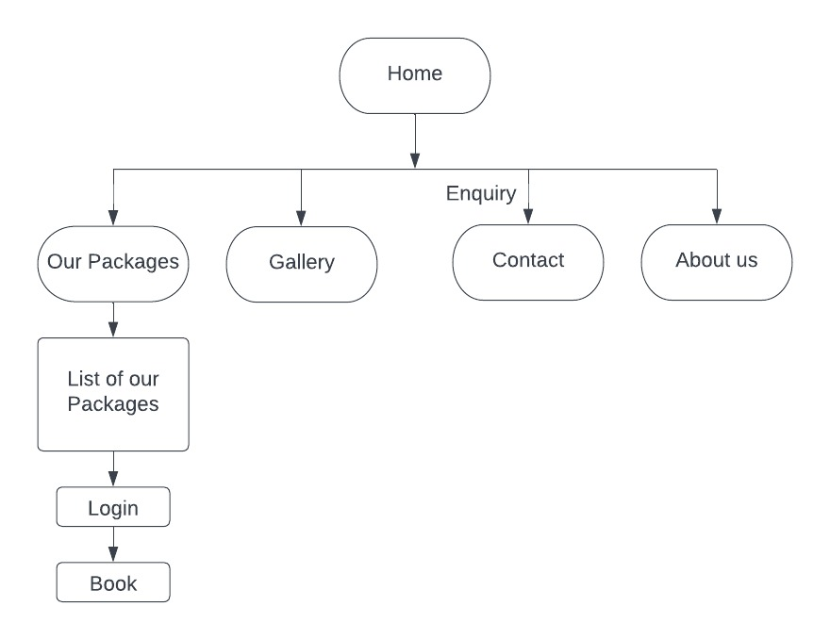

Fig 3.1 : Weekends block diagram

  - ALGORITHM AND PROCESS DESIGN

In our proposed model, we develop every module under the need, design, implementation and testing phases.This model implements the model part by part. The process continues till the entire system is achieved. It involves development. We followed the process model system and develop the system part by part.

Step 1- Home page: First of all we created home page. This is the most important part of our project.

Step 2- User interface design: After we design the user interface for all the users.

Step 3- Adding tourist places information: After that we design the tourist places page and add all information about tourist places of India.

Step 4- Creating attractive packages for travelers: To attract the travelers we design and add many attractive travel packages for our registered travelers. Without registration user can only see the packages but can’t book it. For booking, they have to be registered.

Step 5- Packages: We created affordable packages.

Step 6- Gallery Design: After that we design a photo gallery for introducing the tourist places to the users.

Step 7-Creating contact page: Finally we design a contact page to contact with us for any issues.

  - Details of Hardware and Software

Hardware Details:

1. Edition: Windows 11 Home Single Language.
2. Processor: 12th Gen Intel(R) Core (TM) i5-1240P 1.70 GHz
3. Memory: Sufficient RAM for quick data access( 8-16 GB).
4. Storage: Adequate storage space for image and attendance data (256 SSD).
5. Network Connectivity: Internet or intranet access for data sharing (if needed).
6. System type : 64-bit operating system, x64-based processor.

Software Details:

- Web server Software :- Examples including Xampp Server.

- Programming Languages :- Such as HTML, CSS, JS , PHP.

- Database Management System:- MySQL.

  - Experiment and result for validation and verification

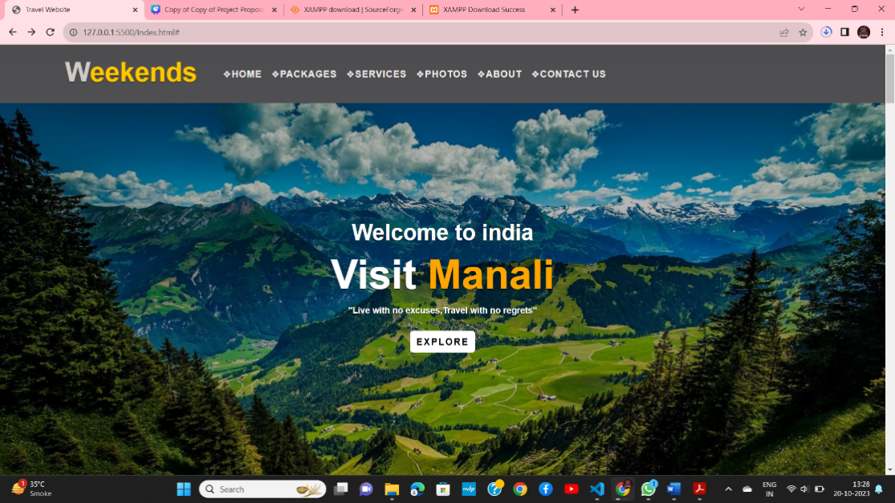
Fig 3.4.1 Home page.

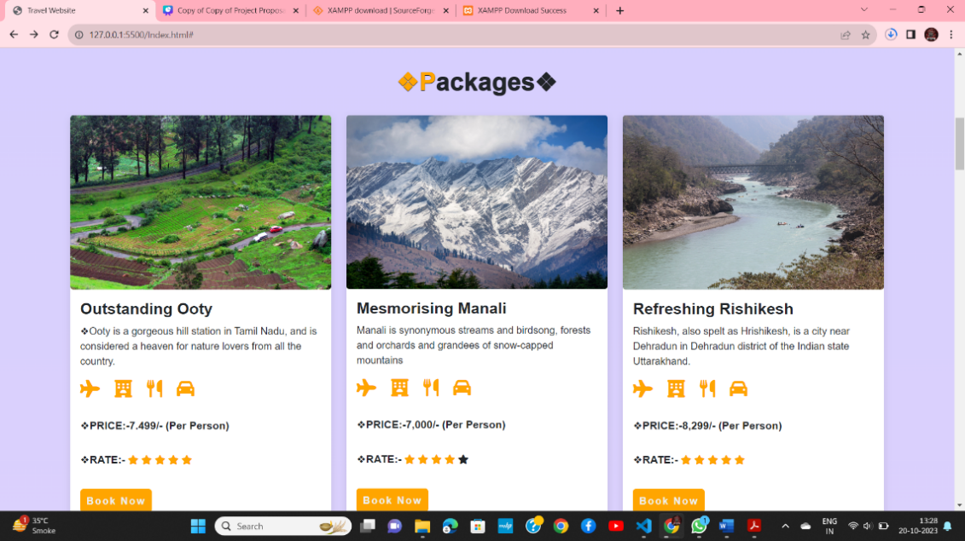
Fig 3.4.2 Packages.

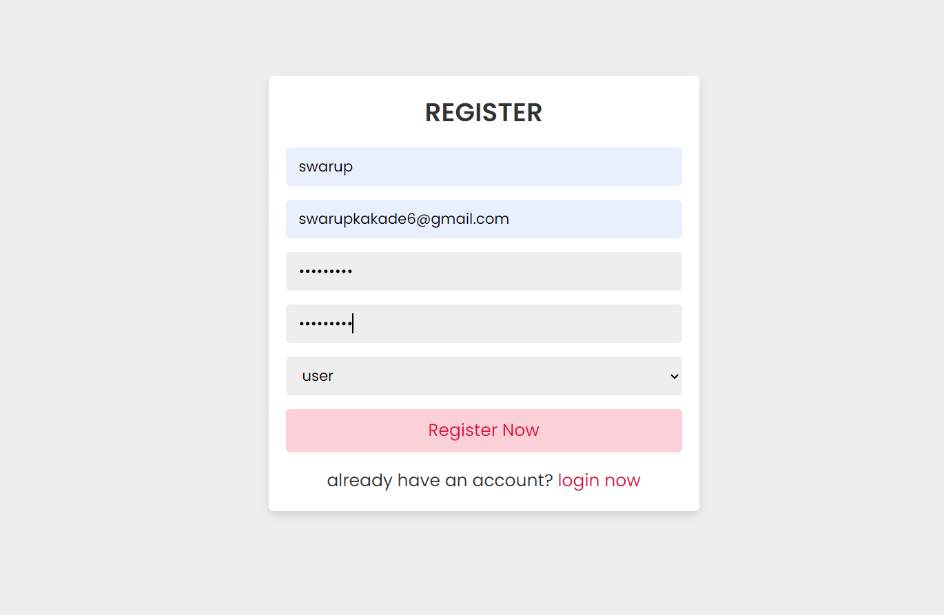
Fig 3.4.3 Registration page.

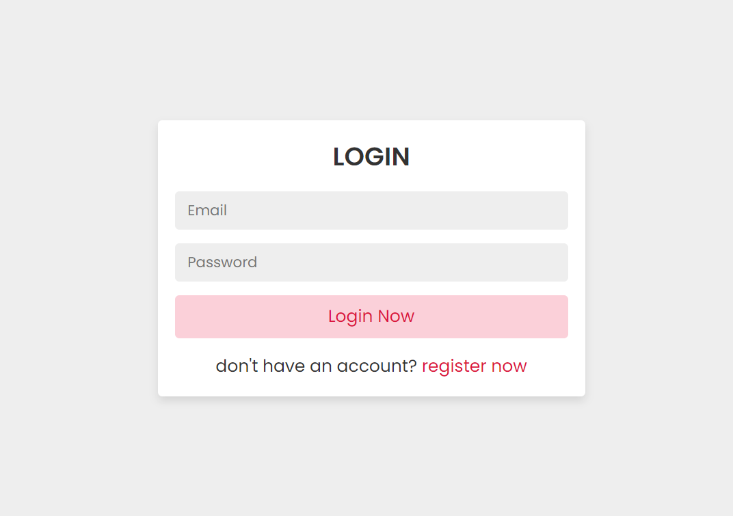
Fig 3.4.4 Login Form.

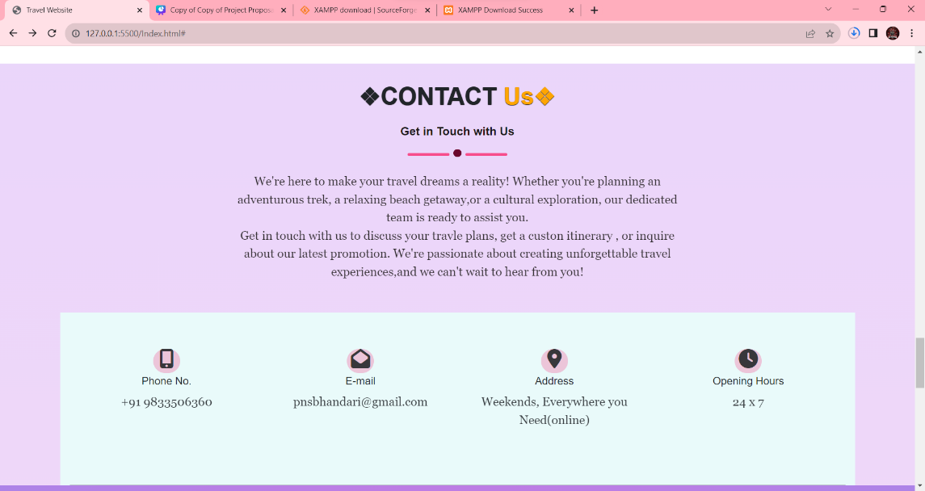
Fig 3.4.5 Contact us.

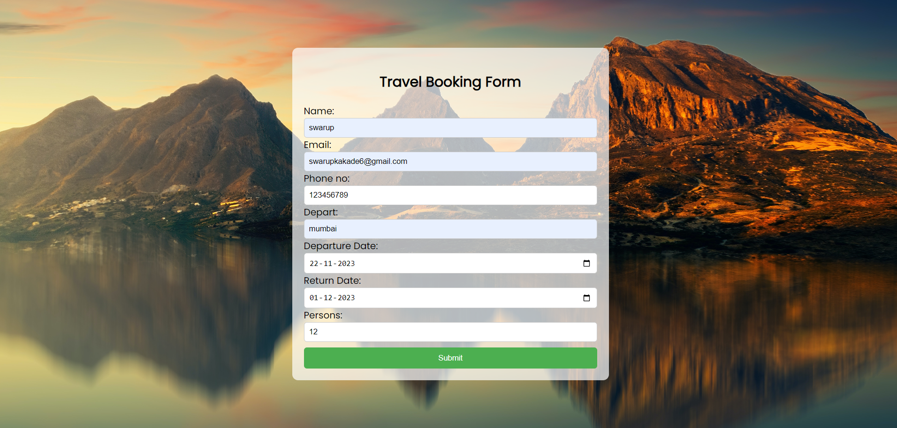
Fig 3.4.6 Booking Form.

  - Analysis

1.User Interface: An attractive interface helps to engaged the user on website.

2.Database Management: Huge amount of data to be consider in any kind of tourist website, So proper management of data is one the important thing so this system arrange and manage the data properly.

3.Security: Every user need to store their data securely so this system helps to keep their data secured.

4.Integration: The integration of different kind of services in single packages helps the user as save their time and money so this system have the tour package system.

5.Scalability: Every website should work properly when more number of people work at a same time on that so in any kind of tour web the user are more and scalability of this system is better.

6. Feedback and Improvement: Feedback is must in any kind of tourist website so this may help to developer to make changes in website to make it more reliable.

  - Conclusion and future work

Conclusion:
Tourism is currently recognized as a global industry which is growing at a high rate like any other industry. Access to relevant and accurate information is at the heart of tourism. Here, the proposed project on Tourism Management System tries to bridge the gap by noting what a tourist perceives as relevant. Hence, the aim of this project entails the design and implementation of a platform that will assist tourists in gaining access to travel to various tourist locations.[10]

It is worth mentioning that this project work is open for further enhancement, with the expectation that it becomes more robust and better enhanced; covering every single tourist sites. For a modified system, the user need to just login into the application and can find the routes ,costs ,hotels ,flights, etc .[10]

In the past, face to face consultations with a travel agent was paramount for booking both leisure and business travel. Technology and global circumstances, such as pandemics, financial collapses, and terrorism, have put pressure on tourism and travel services. But by the system like this helps a lot in the industry of tourism. The tourist can book their tour by the choice within budget without consultation with the travel agent. This may help to grow the tourism industry.

Future Work:

"If given the opportunity, we are committed to enhancing both the aesthetics and precision of the application. Additionally, we will include payment option. Our dedication to ensures that the Tourist Management System will not only be more visually appealing but also more accurate"

4. REFERENCE

[1].ttps://en.m.wikipedia.org/wiki/Travel#:~:text=Travel%20is%20the%20movement%20of,one%20way%20or%20round%20trip , Editor, October 6 ,2023.

[2]. Kuchekar Rutvik Baban, Mehra Prasad Sanjay, Jadhav Anushka Manoj, “TOURS AND TRAVEL MANAGEMENT SYSTEM”, Volume:04,March-2022.

[3]. Madushan S.H.K1, De Alwis Gunathilake W.L.D.C.K2, “Travel Planning Management System”, Volume-12, October 2022

[4]. Payel Rani, Rakib Ahmed, “ Tourism and Travel Management”, Volume 3 , January 2015
https://www.researchgate.net/publication/310122350_Tourism_Maagement_System , Editor, October 8.

[5]. Seden Dogan, “ Online Travel Agencies and their role in Tourism Industry”, Volume:10(3), 2022.

[6]. https://www.tutorialreuplic.com/php-tutorial-login-system.php, Editor,October 15.

